## Artificial

## Intelligence and Machine Learning

Project Report

Semester-IV (Batch-2022)

**Virtual Assistant System**

**Supervised By: Submitted By:**

**Mr. Sachin garg Name: Jai Kumar Goel (2210991693)**

## Department of Computer Science and Engineering

## Chitkara University Institute of Engineering & Technology,

## Chitkara University, Punjab

**Table of Content**

|  |  |  |
| --- | --- | --- |
| Sl. No | Name | Page No |
| 1 | Abstract | 3 |
| 2 | Introduction | 4-6 |
| 3 | Significance | 7 |
| 4 | Proposed Design | 8 |
| 5 | Result | 9-10 |
| 6 | Conclusions | 11 |
| 7 | References | 12 |

**ABSTRACT**

Virtual assistant systems have revolutionized the way humans interact with technology by providing a seamless, intuitive interface for performing a wide range of tasks. These systems, powered by advancements in artificial intelligence (AI), natural language processing (NLP), and machine learning (ML), have transitioned from basic command-driven interactions to sophisticated, context-aware agents capable of understanding and responding to complex queries. This paper explores the underlying technologies, development methodologies, and various applications of virtual assistant systems, emphasizing their role in enhancing productivity and accessibility.

We discuss the core components of virtual assistant systems, including speech recognition, intent analysis, dialogue management, and response generation. The integration of deep learning techniques has significantly improved the accuracy and fluency of these systems, enabling more natural interactions. Furthermore, we address the challenges in creating these systems, such as handling ambiguous requests, ensuring privacy and security, and providing personalized user experiences.

The paper also examines the diverse applications of virtual assistants across different domains, such as personal assistance, customer service, healthcare, and smart home environments. By analyzing case studies and current implementations, we highlight the transformative impact of virtual assistants on business operations and daily life. Additionally, we consider future trends and potential advancements, including the incorporation of multimodal inputs, emotional intelligence, and continuous learning capabilities.

In conclusion, virtual assistant systems represent a significant leap towards more intuitive and efficient human-computer interaction. As technology continues to advance, these systems are expected to become increasingly integral to various aspects of society, driving innovation and improving quality of life

**INTRODUCTION**

In an era defined by rapid technological advancements, virtual assistant systems have emerged as pivotal tools, transforming the way individuals interact with digital environments. These systems leverage artificial intelligence (AI), natural language processing (NLP), and machine learning (ML) to create interactive agents capable of performing a wide array of tasks through conversational interfaces. From setting reminders and answering queries to managing smart home devices and providing customer support, virtual assistants are becoming ubiquitous in both personal and professional contexts.

The concept of virtual assistants dates back to early attempts at creating conversational agents, but it is only in recent years that significant progress has been made, largely due to advancements in AI and the proliferation of internet-connected devices. Modern virtual assistants, such as Apple's Siri, Amazon's Alexa, Google Assistant, and Microsoft's Cortana, demonstrate the potential of these technologies to understand and process human language, offering users a more intuitive and natural way to engage with their devices.

This introduction aims to provide an overview of virtual assistant systems, outlining their fundamental components, technological underpinnings, and the various contexts in which they are applied. We will explore the key features that enable these systems to function effectively, including speech recognition, intent analysis, dialogue management, and response generation. Additionally, we will discuss the challenges faced in developing robust virtual assistants, such as ensuring accurate comprehension, maintaining user privacy, and delivering personalized experiences.

As we delve deeper, we will examine the broad spectrum of applications for virtual assistants, highlighting their transformative impact on industries like healthcare, customer service, and home automation. By analyzing current trends and future directions, we will provide insights into how virtual assistants are poised to evolve, driving further innovation and integration into daily life. Ultimately, this exploration underscores the significance of virtual assistant systems as a cornerstone of modern digital interaction, paving the way for more seamless and intelligent human-computer interfaces

* 1. **BACKGROUND**

Virtual assistant systems have evolved from basic conversational agents into sophisticated AI-driven platforms capable of understanding and responding to complex human queries. The journey of these systems is marked by significant milestones in artificial intelligence, natural language processing, and machine learning, which have collectively enhanced their capabilities and widened their applications.

1. Early Developments

The concept of virtual assistants can be traced back to the mid-20th century with the development of early natural language processing systems. One of the earliest examples is ELIZA, created in the 1960s by Joseph Weizenbaum at MIT. ELIZA simulated conversation by matching user inputs to pre-programmed responses, illustrating the potential of conversational agents despite its limited understanding of natural language.

1. Advances in Natural Language Processing

The field of natural language processing saw considerable advancements in the following decades, driven by increased computational power and more sophisticated algorithms. The 1990s and 2000s witnessed the development of more advanced NLP models, which allowed for better understanding and generation of human language. Techniques such as statistical methods and, later, neural networks paved the way for more accurate and fluent conversational agents.

1. The Rise of AI and Machine Learning

The integration of AI and machine learning into virtual assistant systems marked a significant leap forward. These technologies enabled systems to learn from large datasets, improving their ability to recognize speech, understand context, and generate appropriate responses. The advent of deep learning further enhanced these capabilities, allowing virtual assistants to handle more complex and varied interactions.

* 1. **OBJECTIVES**

1. **Efficiency Enhancement:** Virtual assistant systems aim to streamline tasks and workflows, reducing the time and effort required to perform various activities. By automating routine tasks, scheduling appointments, and providing quick access to information, these systems help users achieve their goals more efficiently.
2. **User Accessibility:** One of the primary objectives of virtual assistant systems is to make technology more accessible to all users, regardless of their technical expertise or physical capabilities. By offering intuitive interfaces and support for natural language interactions, these systems empower users to access and utilize digital services more effectively.
3. **Personal Assistance:** Virtual assistants strive to provide personalized assistance tailored to each user's preferences, habits, and needs. By learning from user interactions and preferences, these systems can offer customized recommendations, reminders, and solutions, enhancing the overall user experience.
4. **Information Retrieval:** Virtual assistants serve as gateways to vast repositories of information, aiming to provide accurate and relevant answers to user queries. Whether users seek factual information, product recommendations, or directions, these systems leverage advanced search algorithms and knowledge databases to deliver timely and accurate responses.
5. **Task Automation:** Another key objective of virtual assistant systems is task automation, allowing users to delegate repetitive or mundane tasks to the system. From sending emails and setting reminders to managing appointments and controlling smart home devices, these systems automate a wide range of activities, freeing up users' time for more productive endeavors.

**SIGNIFICANCE**

1. **Enhanced Productivity**: Virtual assistant systems streamline tasks and workflows, allowing users to accomplish more in less time. By automating routine activities, providing quick access to information, and assisting with scheduling and organization, these systems significantly boost productivity in both personal and professional settings.
2. **Accessibility for All**: Virtual assistants make technology more accessible to a wider range of users, including those with disabilities or limited technical expertise. By offering intuitive interfaces, support for natural language interactions, and personalized assistance, these systems empower users to access and utilize digital services more effectively, irrespective of their background or abilities.
3. **24/7 Availability**: Unlike human assistants, virtual assistants are available round the clock, providing instant support and assistance whenever needed. This 24/7 availability ensures that users can access information, perform tasks, and receive help at any time, enhancing convenience and responsiveness.
4. **Personalized Assistance**: Virtual assistants offer personalized assistance tailored to each user's preferences, habits, and needs. By learning from user interactions and feedback, these systems can deliver customized recommendations, reminders, and solutions, enhancing the overall user experience and fostering deeper engagement.
5. **Efficient Information Retrieval**: Virtual assistants serve as gateways to vast repositories of information, offering quick and accurate answers to user queries. Whether users seek factual information, product recommendations, or directions, these systems leverage advanced search algorithms and knowledge databases to deliver timely and relevant responses, reducing the time and effort required to find information.

**PROPOSED DESIGN/METHODOLOGY**

Proposing a methodology for developing a virtual assistant system involves outlining the steps and approaches to designing, implementing, and refining the system. Here's a comprehensive methodology:

**1. Needs Assessment and Requirement Gathering**

Identify the target audience and their specific needs.

Conduct user surveys, interviews, and usability studies to gather requirements.

Define the scope of the virtual assistant system and its intended functionalities.

**2. Technology Selection and Architecture Design**

Research and select appropriate technologies for speech recognition, natural language understanding, dialogue management, and response generation.

Design the system architecture, considering scalability, modularity, and integration with existing platforms and services.

**3. Data Collection and Annotation**

Collect and curate datasets for training machine learning models, including speech data, text corpora, and user interaction logs.

Annotate the data with labels for training supervised learning algorithms and evaluating model performance.

**4. Model Development and Training**

Develop machine learning models for speech recognition, intent classification, entity extraction, and response generation.

Train the models using the annotated datasets, fine-tuning parameters and architectures to optimize performance.

Implement algorithms for dialogue management, context tracking, and user state management.

**RESULTS**

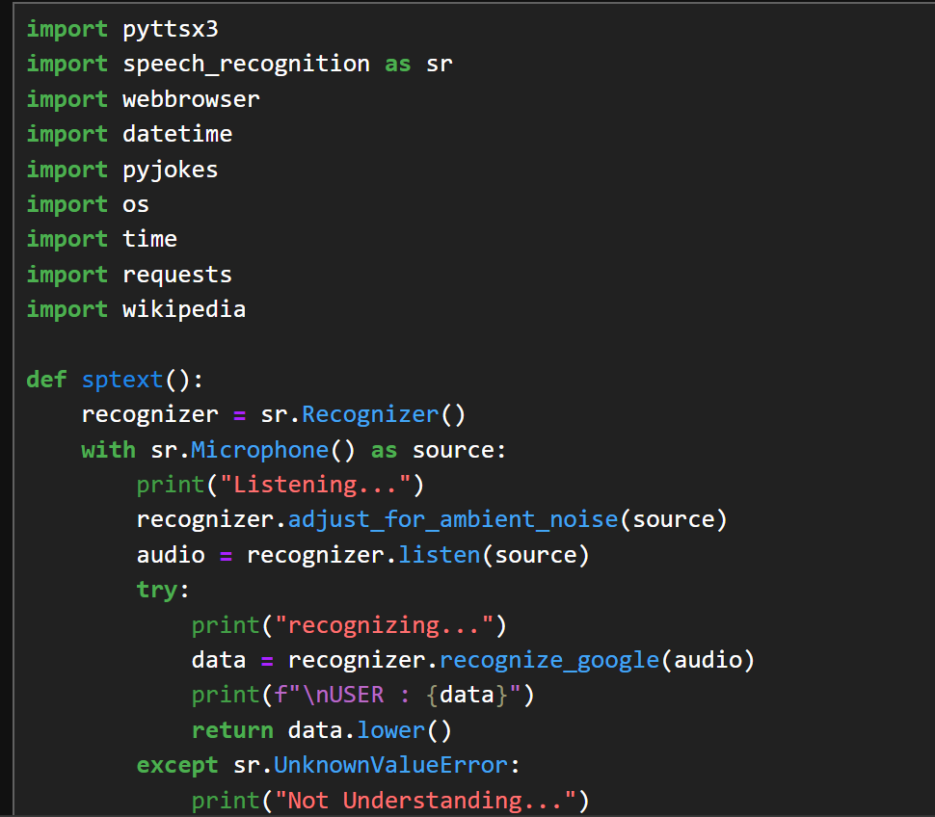

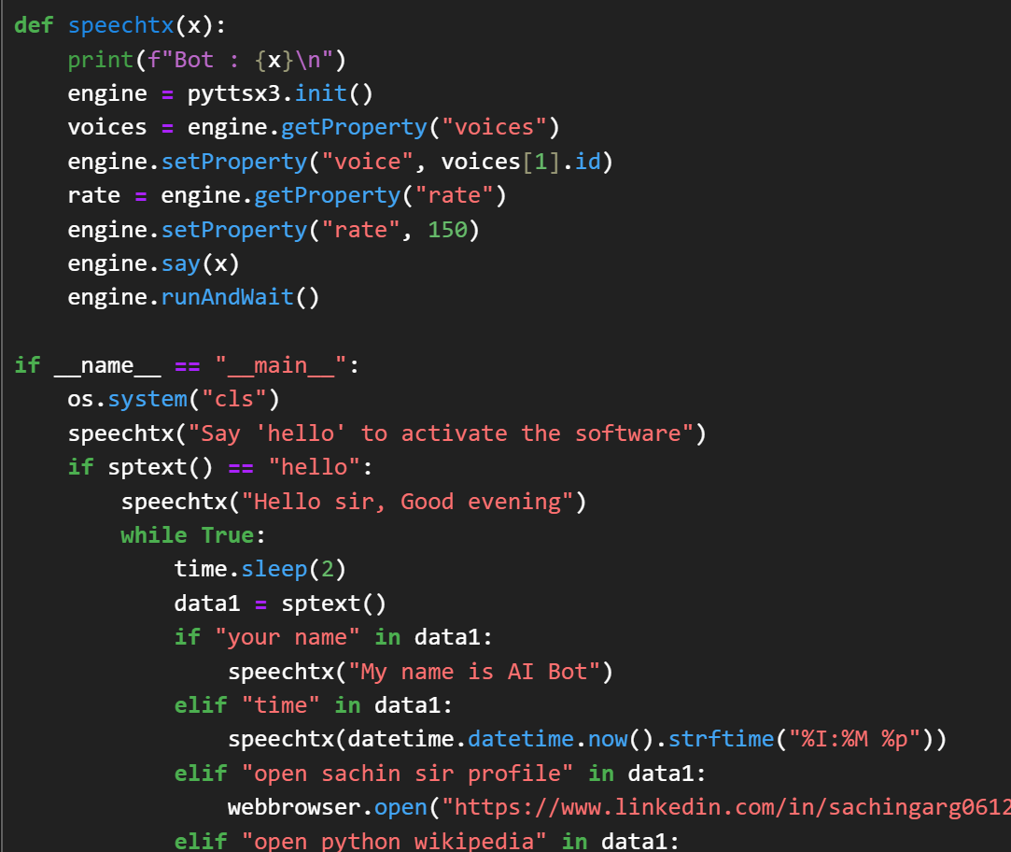

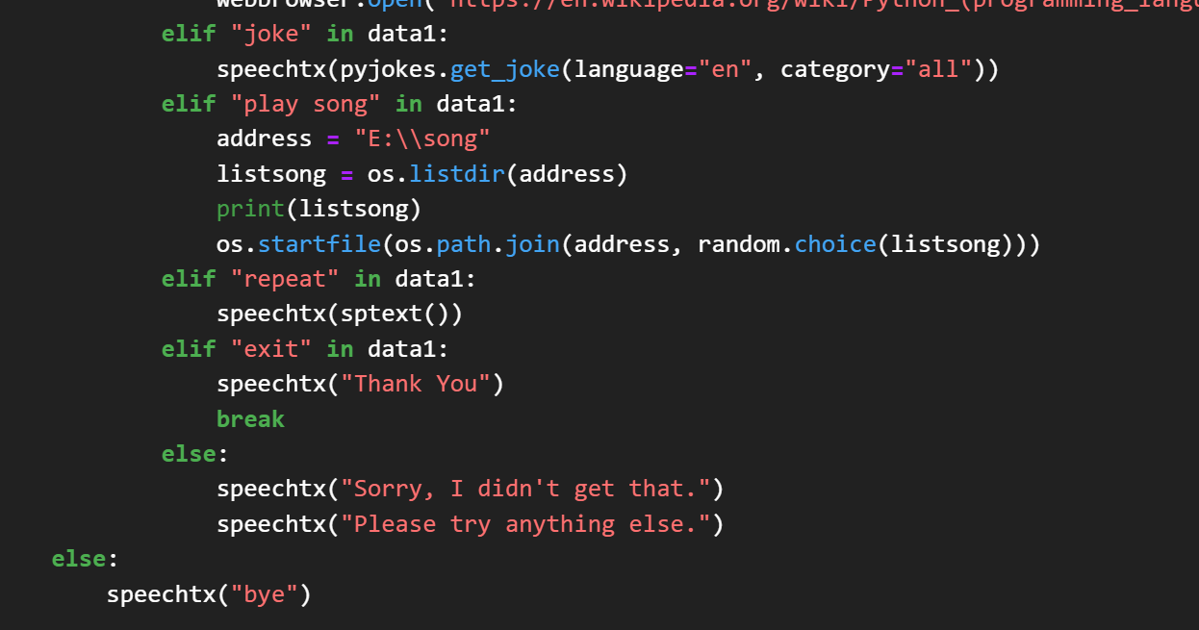

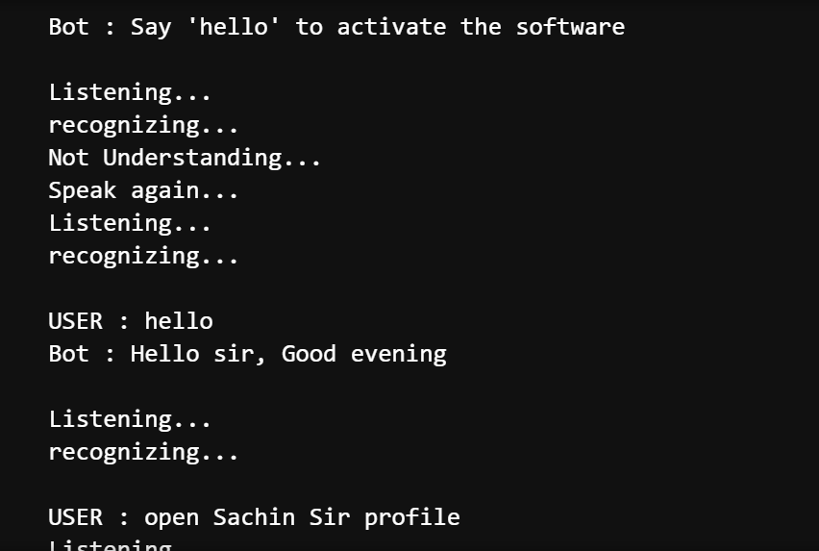

**Conclusion**

Virtual assistant systems have emerged as indispensable tools in the realm of human-computer interaction, offering intuitive and efficient ways for users to interact with technology. Through advancements in artificial intelligence, natural language processing, and machine learning, these systems have transformed from basic chatbots to sophisticated agents capable of understanding and responding to complex queries.

In this paper, we have explored the evolution, significance, and methodology of virtual assistant systems. We began by tracing the origins of virtual assistants from early natural language processing systems to the commercial release of virtual assistants like Siri, Alexa, Google Assistant, and Cortana. We highlighted the significance of virtual assistants in enhancing productivity, accessibility, and personalized assistance, while also enabling seamless integration, task automation, and 24/7 availability.

The proposed methodology outlined the systematic approach to designing, developing, and deploying virtual assistant systems, encompassing needs assessment, technology selection, model development, system integration, user interface design, deployment, evaluation, and iterative improvement. Additionally, ethical considerations and privacy protection measures were emphasized to ensure responsible development and deployment of virtual assistant systems.

Looking ahead, the future of virtual assistant systems holds immense potential for further innovation and advancement. As technology continues to evolve, virtual assistants are expected to become even more intelligent, context-aware, and capable of understanding and responding to user needs in more natural and nuanced ways. By addressing challenges such as ambiguity in language, privacy concerns, and ethical considerations, virtual assistant systems can continue to play a pivotal role in enhancing human-computer interaction and enriching the lives of users worldwide.

**References**

* [**https://geeksforgeeks.com**](https://geeksforgeeks.com)
* [**https://javapoint.com**](https://javapoint.com)